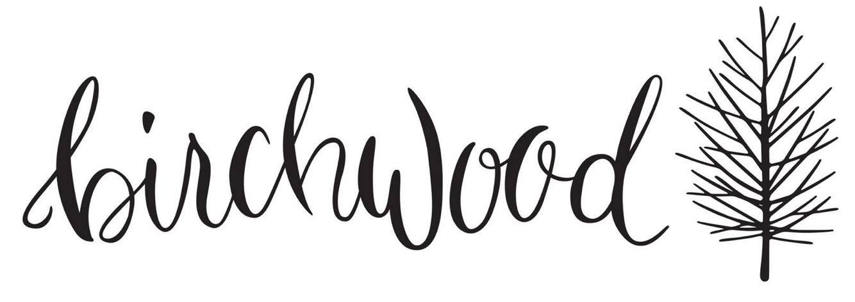
Drinks

Hey hot stuff!

COFFEE by Lonsdale St. Roasters
Black. we pour seasonal single O.
Espresso $3
Long black $3.5
White. Smith & Evans blend
Flat and white $4
Cappuccino $4
Latte $4
Hot chocolate $4.5
Chai latte $4
Turmeric latte $4.5

Large, strong, decaf $0.5
Soy milk, almond milk, coconut milk $0.5

TEA by Ovvio $3.5
English breakfast, earl grey, chai, peppermint, camomile,
lemongrass & ginger, green.
Chai tea brewed on milk $4.5

ICE ICE BABY!
Frappe. Salted caramel, coffee, milk, ice $7
Iced coffee. Coffee, milk, icecream, cream $7
Iced latte. Coffee, milk, ice $4.5
Iced chai. Chai, milk, ice $4.5

FRESH JUICE. Todays mix or make your own $7

KOMBUCHA. House-made. Ask us our flavours $5

SMOOTHIES. $8.5
Green machine. Spinach, kale, cucumber, mint, banana & fresh apple
Banana Split. Banana, peanut butter, cacao, oats, honey & almond milk
Strawbs & cream. Strawberries, banana, dates, vanilla & coconut milk

SHAKEN MILK.
chocolate, strawberry, caramel, vanilla $6

SOFT DRINK.
Coke, diet coke, lemonade $4
Bundaberg ginger beer, lemon, lime & bitters $4.5
San Pellegrino mineral water 600ml $6

Drinks

Hey hot stuff!

COFFEE by Lonsdale St. Roasters
Black. we pour seasonal single O.
Espresso $3
Long black $3.5
White. Smith & Evans blend
Flat and white $4
Cappuccino $4
Latte $4
Hot chocolate $4.5
Chai latte $4
Turmeric latte $4.5

Large, strong, decaf $0.5
Soy milk, almond milk, coconut milk $0.5

TEA by Ovvio $3.5
English breakfast, earl grey, chai, peppermint, camomile,
lemongrass & ginger, green.
Chai tea brewed on milk $4.5

ICE ICE BABY!
Frappe. Salted caramel, coffee, milk, ice $7
Iced coffee. Coffee, milk, icecream, cream $7
Iced latte. Coffee, milk, ice $4.5
Iced chai. Chai, milk, ice $4.5

FRESH JUICE. Todays mix or make your own $7

KOMBUCHA. House-made. Ask us our flavours $5

SMOOTHIES. $8.5
Green machine. Spinach, kale, cucumber, mint, banana & fresh apple
Banana Split. Banana, peanut butter, cacao, oats, honey & almond milk
Strawbs & cream. Strawberries, banana, dates, vanilla & coconut milk

SHAKEN MILK.
chocolate, strawberry, caramel, vanilla $6

SOFT DRINK.
Coke, diet coke, lemonade $4
Bundaberg ginger beer, lemon, lime & bitters $4.5
San Pellegrino mineral water 600ml $6

